# Introduction

The website I’ve chosen to create for this Semester 2 assignment is a tribute the Sam Raimi “Spider-Man Trilogy” films. The main motivation for this is to show as to why I believe these films are some of the best ever made and are leagues above any marvel films we get today, besides the select few.

The Websites layout will be as follows:

**Home Page**, short greeting and images. **Sam Raimi**, biography of the directiors ambitions and brief history. **Characters**, outline the protagonists and antagonists of the films and what role they have played.

**Best Moments,** highlighting the biggest moments of the films and why they were so great. **Spider-Man 4,** form page getting the viewer involved in the discussion on what a “Spider-Man 4” film could have been.

# GitHuB – must be included in order to mark your web project

GitHub URL to open your website on a browser

<https://jakey2k.github.io/SpiderManWebsite/>.

URL of your GitHub Repository

git@github.com:JakeY2k/SpiderManWebsite.git

# Original Mockup Sketch of Website home page

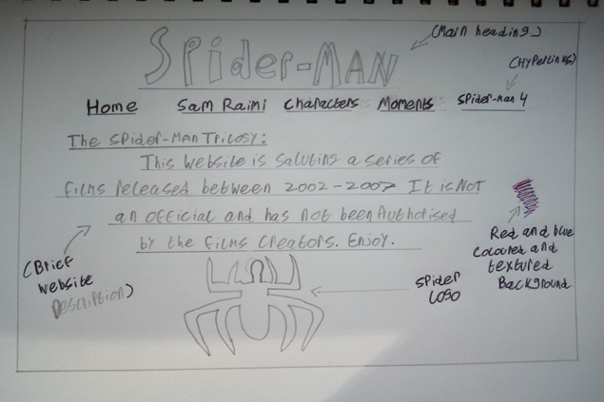

# Website Described

All Information used have been taken form the Spiderman Wiki Website, YouTube and Google Images - <https://spiderman.fandom.com/wiki/Spider-Man_Wiki>

Page 1 – **Home Page**, Brief Description of Website, Welcome Message and short biography of the three main characters and director with photos.

Page 2 – **Sam Raimi,** Past Films with promotion posters, Motivations for Spider-Man Films, Backstory.

Page 3 – **Characters**, Other heroes and Antagonists with photos besides the main trio shown on the home page and their Involvement in the films.

Page 4 – **Best Moments,** Iconic and wellremembered moments from the series, shown in photos and videos and why they were so iconic.

Page 5 – **Spider-Man 4,** Form the visitor can fill out to **s**hare their ideas and thoughts on what a potential fourth film in the series could have been like. Google map showing Marvel Studios location.

# HTML5 Validation Results for each Webpage

Page 1 – –Validations result

Page 2 – Validation result

Page 3 – Validation result

Page 4 – Validation results

Page 5 – Validation results

# CSS Validation Results

|  |
| --- |
| **\*\*\*\*Must include Report including purpose and intended audience of the website and sources of images and information of each web page and HTML & CSS validation results. Upload entire project to GitHub and upload GitHub url in report** |
| **Minimum of 4 HTML Pages with navigation menu** |
| **Upload progress and completed website to your GitHub account** |
| **HTML5 standards and recommended page layout structure** |
| **Include appropriate Meta data – description & appropriate keywords etc to improve pages SEO** |
| **Include font family for web page body** |
| **Appropriate use of External Style Sheet – Recommended CSS** |
| **Appropriate use of Internal & Inline Styling on HTML page** (used in all pages for the background image and footer.) |
| **Home page content aligned to each other and visually attractive** |
| **Include navigation above fold and bottom of web pages- Indicate on navigation the current page** |
| **Include both Class and ID as CSS Selectors** (class used for header, black highlighter behind “Sam Raimis Spider-Man Trilogy 2002 – 2007” text & ID (#Spider-Man 4) to order the page.) |
| **Consistency of design on all pages , use of fonts, colour etc** |
| **Appropriate use of Headings (h1, h2, h3, h4)** |
| **Appropriate use of Colours (test for colour blind users)** |
| **Include an article or section with 2 or 3 columns** (Home Page) |
| **Include logo and display in header of page** |
| **Clear, consistent and align content on all pages** (  <https://spiderman.fandom.com for character information, Google images for pictures used> |
| **Include images (with at least one image floated with text alongside)** |
| **Use of background image** (used on all pages as a red texture) |
| **Include table of data/information** on |
| **Include lists ordered or unordered (different shaped bullet points)**  (used on page 2 “Sam Raimi” When listing his accomplishments, ambitious and goals.) |
| **Include a link to a suitable video and google map** (page 3 “Gallery” displaying best moments. Page 4 “spider-man 4” link to official Marvel website and headquarters) |
| **Include a contact me form and include red * beside required/mandatory input fields** |
| **Verify data collected on contact form, using get and data attached to URL** |
| **Footer information include Copyright© 2020 and navigation** |
| **Internal anchor Links on one of the webpages** |
| **External Link** |
| **Any Additional Features included** |
| **Results included in report of HTML5 Validation (with majority of issues addressed)** |
| **Results included in report of CSS Validation (with majority of issues addressed)** |
| **☐ Include Favicon on the Title tab** | |
| **Guide line on Website appearance, design and Content** [**https://webdesignledger.com/10-signs-of-a-user-focused-design/**](https://webdesignledger.com/10-signs-of-a-user-focused-design/) | |
| **Guidelines on Website overall appearance & design** [**https://webdesignledger.com/20-dos-and-donts-of-effective-web-design/**](https://webdesignledger.com/20-dos-and-donts-of-effective-web-design/) | |